4 -2 Milestone 3: Enhancement Two: Algorithms and Data Structure
Victor Haro Justiniano
SNHU
Cs499 Computer Science Capstone
Sherri Maciosek
04 /3/ 2026

For this enhancement, I used the inventory mobile application that I originally created in CS 360. This artifact was a good fit for the algorithms and data structure category because the app already stored and displayed inventory records, which gave me a clear way to improve how the data was handled once the list started growing. In its earlier stage, the app could add, edit, delete, and display items, but it showed the full list all at once and did not give the user an efficient way to narrow results down. For this enhancement, I improved the inventory screen by adding search, sorting, and low stock filtering so the user can manage items more easily and find what they need faster.
I chose this artifact for my ePortfolio because it shows a practical improvement to a project that already had a working foundation. Instead of changing the whole design, I built on what was already there and focused on making the inventory data easier to work with. The main improvement was adding a process that loads the item list, applies a search value, filters it when low stock mode is turned on, and then sorts the results based on the option the user selected. This helped move the screen from just being a basic list into something more useful and organized. It also shows my skills in working with collections of data, conditional logic, sorting behavior, and processing based on user input. The app improved because the user no longer has to scroll through every saved item just to find one entry or check which items are running low.
This enhancement aligned best with Course Outcomes 4 and 5. It supported Outcome 4 because I used practical development techniques to improve the app in a way that actually helps the user. I focused on making the inventory data easier to search, sort, and go through. It also supported Outcome 5 because the enhancement changed how stored records were handled depending on the user’s search text, selected sort mode, and low stock filter. After completing the enhancement, I still feel Outcomes 4 and 5 are the best fit.
One of the main challenges during this enhancement was making sure the new search, sort, and filter features worked correctly during testing. As shown in Image 1, the search behavior was not fully matching the selected mode, and date sorting was also off because the code only handled one date format. I fixed that by updating the filtering logic so the search could better match quantity and date values when those modes were selected, and I also revised the date parsing method to support both short and full year date formats, as shown in Image 2. After those changes, the app returned more accurate search results and sorted dates correctly during testing, as shown in Image 3. A separate issue came up with the low stock checkbox. At first, it was not reloading the inventory list right away when checked or unchecked. To help confirm the best way to handle that behavior, I reviewed a source on checkbox state changes in Android, which supported using a checked change listener so the list would refresh immediately when the filter changed (Annerajb, 2019). That update is shown in Image 4, and Image 5 shows the low stock filter behaving more like a true toggle after the fix. Working through these issues helped me better understand how closely connected search, sorting, and filtering logic are, and how testing each part separately made the final behavior more reliable.

Image 1: During testing, the search and date handling logic needed adjustment. Quantity and date searches did not behave as expected, and date sorting was not correct because the code only handled one date format.
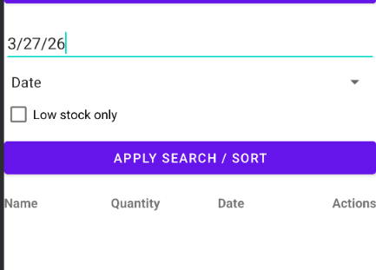
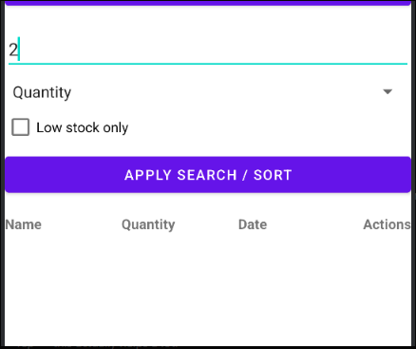

Image 2: To improve this behavior, I updated the filtering logic so search results followed the selected mode more clearly, and I revised the date parsing method to support both short and full year date formats.
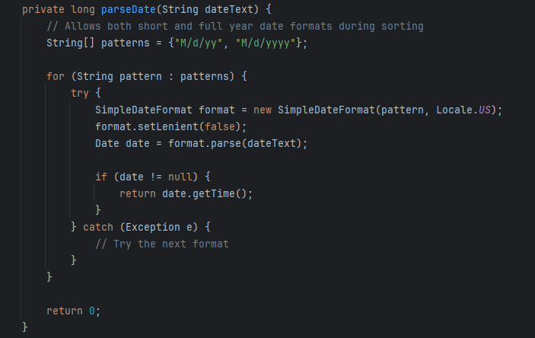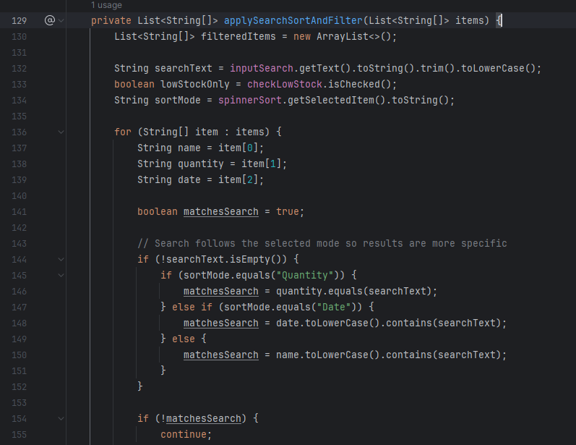

Image 3: After updating the filtering and date parsing logic, the app produced more accurate search results and sorted dates correctly during testing.
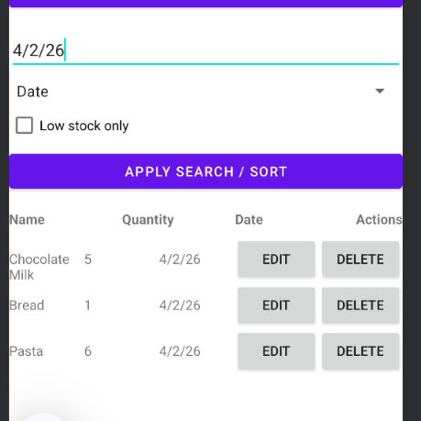
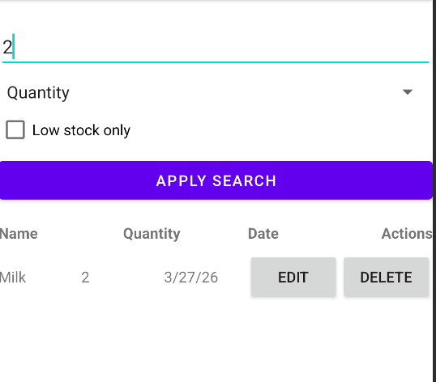
Image 4: The low stock checkbox was updated to reload the inventory list immediately when it's checked or not .
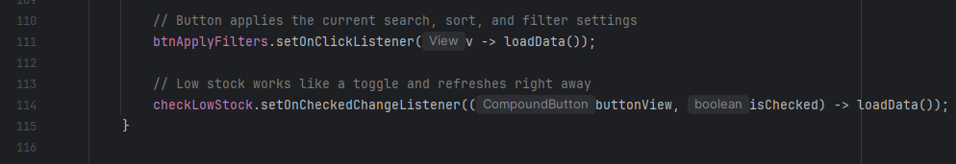
Image 5: After this change, the low stock filter behaved more like a true toggle and updated the list right away.

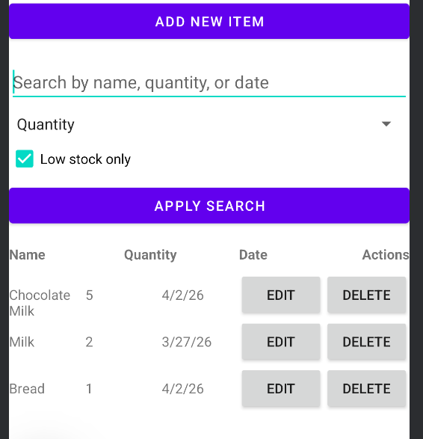

Resources-
Annerajb. (2019, February 26). How to receive a event on android checkbox check change? Stack Overflow. https://stackoverflow.com/questions/3149414/how-to-receive-a-event-on-android-checkbox-check-change

